Musculoskeletal Test Revision

Describe how a muscle contracts and including the energy process that happens

______________________________________________________________________________________

______________________________________________________________________________________

______________________________________________________________________________________

Describe the joint types in the vertebrae

______________________________________________________________________________________

______________________________________________________________________________________

Describe how muscles for movement must work together

______________________________________________________________________________________

______________________________________________________________________________________

Compare and contrast adduction and abduction

______________________________________________________________________________________

______________________________________________________________________________________

______________________________________________________________________________________

______________________________________________________________________________________

Describe the following joints

gliding joint _____________________________________________________________________________

pivot joint ______________________________________________________________________________

hinge joint ______________________________________________________________________________

ball and socket joint ______________________________________________________________________

What bones make up the axial skeleton? ______________________________________________________

What bones make up the appendicular skeleton? _______________________________________________

Describe the following bones

scapula ________________________________________________________________________________

sternum ________________________________________________________________________________

pelvis __________________________________________________________________________________

sacrum _________________________________________________________________________________

Describe the sliding filament model of muscle contraction

_______________________________________________________________________________________

Compare and contrast the bones in the fingers and the toes

______________________________________________________________________________________

______________________________________________________________________________________

Describe

epiphysis _______________________________________________________________________________

diaphysis _______________________________________________________________________________

Describe how the quadriceps and hamstrings work together

______________________________________________________________________________________

______________________________________________________________________________________

In skeletal muscle contraction, the role of calcium ions is very important. Name the internal cellular structure that stores calcium ______________________________________________________________

Describe how the three different types of muscle would look under a microscope

______________________________________________________________________________________

______________________________________________________________________________________

______________________________________________________________________________________

______________________________________________________________________________________

What distinguishes muscle tissue from all other tissue in the body?

______________________________________________________________________________________

______________________________________________________________________________________

What are thick myofilaments made of? ______________________________________________________

Describe the three different types of cartilage

______________________________________________________________________________________

______________________________________________________________________________________

______________________________________________________________________________________

A muscle is made up of bundles of these structures held together by connective tissue ________________

What bones make up the shoulder girdle (or pectoral girdle)

______________________________________________________________________________________

What are joints that don’t move called, what are joints that do move called

______________________________________________________________________________________

Be able to label a long bone, smooth bone and a flat bone. Include the following parts: diaphysis, epiphysis, marrow cavity, articular cartilages, compact bone, spongy bone, bone marrow and periosteum.

Described the movement and location of synovial joints

______________________________________________________________________________________

______________________________________________________________________________________

______________________________________________________________________________________

______________________________________________________________________________________

______________________________________________________________________________________

______________________________________________________________________________________

Name the five main functions of the skeleton. Give an example which illustrates each function.

|  |  |
| --- | --- |
| Functions of the skeleton | Example |
|  |  |
|  |  |
|  |  |
|  |  |
|  |  |

Label the attachments marked A to F on the diagram below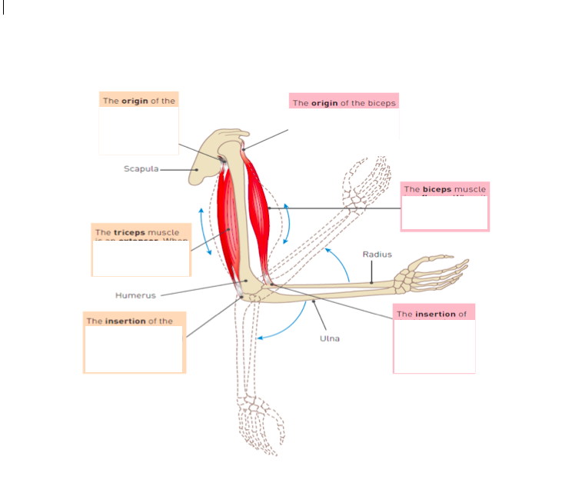

This is a representation of a muscle unit

What happens at

S ___________________________________________________________________________________

A ___________________________________________________________________________________

H ___________________________________________________________________________________

M ___________________________________________________________________________________

I ____________________________________________________________________________________

What happens at A when the muscle contracts? ______________________________________________

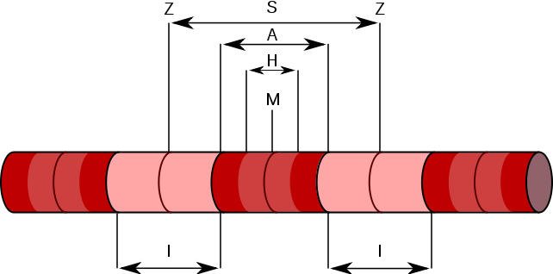

The irregular lines on the skull indicate where different bones join. What is the name given to this type of joint found in the skull? _________________________________________________________________

Bone is what type of tissue? What other parts of the body are this type of tissue? ____________________

_______________________________________________________________________________________

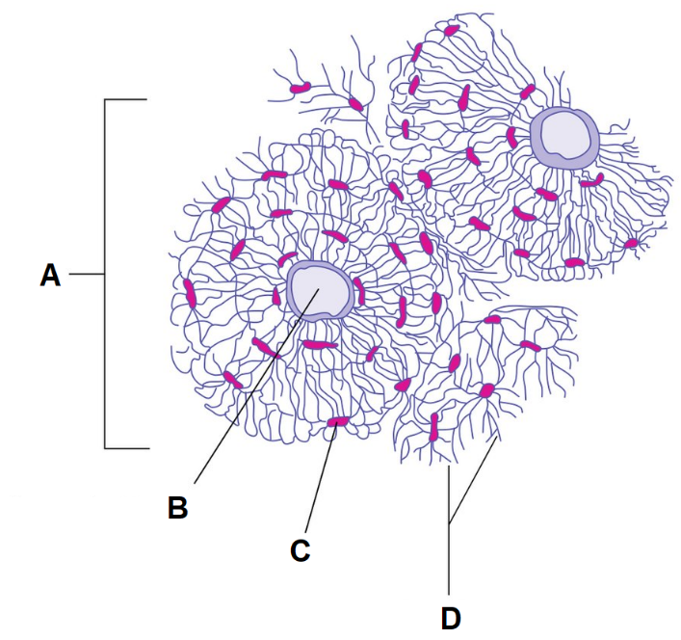Label each part of this Illustration of bone

A ________________________________

B ________________________________

C ________________________________

D ________________________________

Calcium is deposited by bone cells along

with collagen to give bone its stiffness.

Where does this deposition occurs?

It is often said that a broken bone is better than a tear in cartilage. Discuss why bone heals faster than a tear in cartilage. _______________________________________________________________________

_______________________________________________________________________________________

_______________________________________________________________________________________

Describe the differences in structure between compact and spongy bone.

_______________________________________________________________________________________

_______________________________________________________________________________________

_______________________________________________________________________________________

_______________________________________________________________________________________

What type of joint is the knee joint? ________________________________

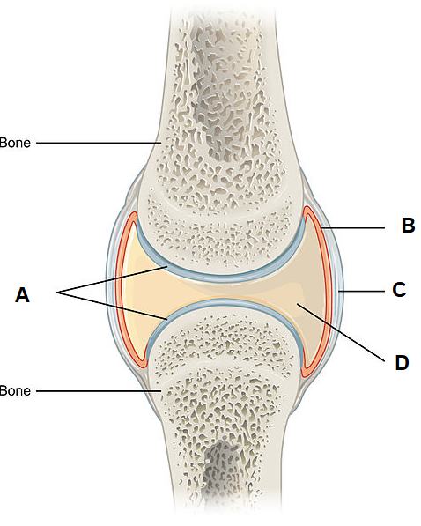 Name the structures at

A __________________________________

B __________________________________

C __________________________________

D __________________________________

Describe how the structures labelled B and D prevent injury to these types of joints.